**Precision Oncology Colorectal Cancer Clinical Study**

*Sponsored by Colorectal Cancer Alliance (CCA) and Perthera in partnership with Oncologists from across the US*

# Clinical Study Overview

The goal of this multi-institutional initiative is to deliver best-in-class Precision Medicine to patients diagnosed with colorectal cancer requiring molecular profiling, to improve patient outcomes, and to advance clinical research. The Program will utilize the Perthera Platform (which seamlessly integrates with any molecular lab of choice), harmonize molecular testing results, and operationalize the collection of real-world outcomes. The Study will empower oncologists to improve patient outcomes, expand enrollment into numerous clinical trials, advance the boundaries of Precision Medicine, and build a collaborative approach with other leading physicians, patients, hospitals, CCA, Perthera, and industry.

# Key Roles for Participating Oncologists

* ***Publications***: lead & support publication efforts using real-world clinical data from across a number of institutions
* ***Enrollment***: easily enroll your patients diagnosed with colorectal cancer, in both academic & community settings
* ***Leadership***: spearhead investigator-initiated trials, determine advances in therapy, & participate in publications

**Clinical Study Objectives**

1. ***Enroll*** ***Patients*** with colorectal cancer into CCA/Perthera global Precision Medicine Program
2. ***Improve Patient Outcomes*** across colorectal cancer through innovative Perthera Platform
3. ***Discover New Predictors*** ***& Therapies*** and evaluate the actionability of emerging biomarkers
4. ***Optimize Molecular Profiling*** and precisely-matched therapies in clinical practice
5. ***Increase Trial Enrollment*** for all patients of participating physicians & hospital systems

**Working Timeline**

1. **Physician Enrollment to join Clinical Study** Present – January 1, 2021
2. **Finalize Study Objectives & Goals** January 1, 2021
3. **Begin Enrolling Patients into Clinical Study**  November 1, 2020 Forward
4. **Review & Utilize Study Findings**  Quarterly starting July 1, 2021
5. **Submission of Study Findings for Publications**  Q3, 2021 & Onward

## Overview of the Perthera Precision Oncology Platform

Simply order & Perthera does the rest using the Platform detailed below:

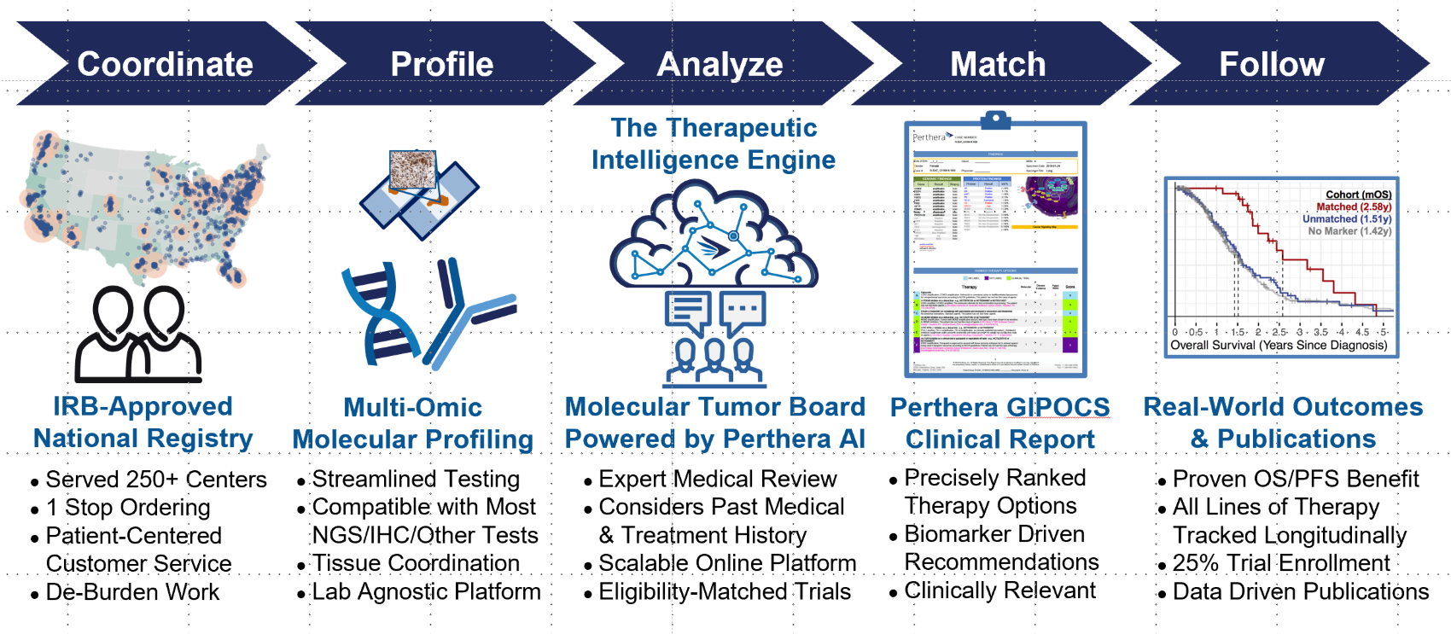

## Proven to Advance Scientific Research using Perthera Platform & Real-World Data

Platform proven to deliver clinical breakthroughs in other areas & looking to do the same in colorectal cancer

**For more information and/or participate in the Clinical Study**

Contact: Gary Gregory **ggregory@Perthera.com** 508.397.8885