You have elected to use Perthera’s Precision Oncology Platform to advance your care.

Who is Perthera?
- A Precision Oncology company utilizing Artificial Intelligence (AI) to generate ranked treatment recommendations personalized for your specific cancer
- Recommendations are clinically proven to extend patient lives and outcomes
- Used by over 250 Cancer Treatment Centers and 10% of oncologists across all 50 states
- With a 5 minute call, Perthera has everything we need to advance your care to a best-in-class level

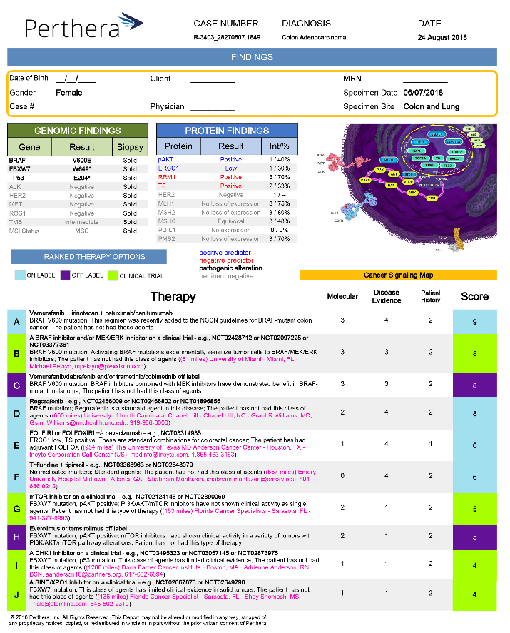
What Will Perthera Do for Me?
- Better Outcomes
  - Proven in numerous clinical studies to advance patients’ overall & progression-free survival
- Personalized Treatment Recommendations
  - Treatment options are precisely matched to you, your molecular profile, and treatment history
  - Ranked therapy options provided at no cost
  - Simple & concise Report delivered to help guide your medical decision making
- Treatment Concierge Services
  - Sign the consent, and Perthera does the rest!
  - We coordinate the entire process once the simple, one-page consent is completed
  - Lab testing is seamlessly coordinated, and our Report delivered within 2 days of the results
- Find the Right Treatments & Clinical Trials for You
  - Clinical trials have been proven to dramatically extend patient survival rates
  - Perthera’s Report precisely matches patients to treatments and clinical trials to support your doctor’s medical decision making and your care pathway
  - Recommendations are personalized for your location and tumor profile for precise matching to the best treatments and trials for you
- Advance Research & Science
  - Perthera tracks and captures your improved outcomes to advance cancer care for all patients across the country through research and publications

How Do I Get Started?
- Please expect a brief call from Perthera’s Clinical Team to review consenting and the next steps.
- After a 5 minute call, Perthera will handle the rest & deliver your personalized treatment options.
- If you have any questions, email Perthera at Hope@Perthera.com or call (571) 252-8343 to speak directly to one of our highly trained Clinical Coordinators.

Perthera has been ordered to advance your care at no cost to you!

